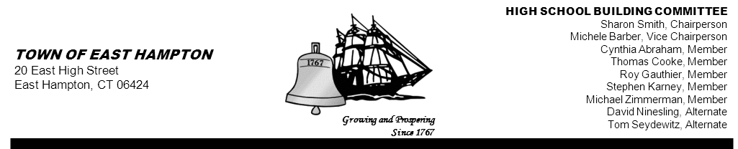

HIGH SCHOOL—ADDITION & RENOVATE-AS-NEW
BUILDING COMMITTEE MEETING
High School (Library)
15 North Maple Street, East Hampton, CT 06424
Minutes
Thursday, September 26, 2013, 5:30 p.m.

PRESENT AT MEETING
Committee Members: Sharon Smith, Chairperson; Michele Barber, Vice Chairperson; Cynthia Abraham, Tom Seydewitz, Michael Zimmerman, Roy Gauthier, Thomas Cooke, and David Ninesling

Member(s) Absent: Stephen Karney

Also Present: Jim Giuliano, CREC Senior Project/Program Manager; Glenn Gollenberg, SLAM Principal In Charge; Amy Samuelson, SLAM Associate; Michael MacDonald, Downes Construction NCARB; John Fidler, High School Principal; Diane Dugas, Superintendent of Schools; Michael Maniscalco, Town Manager

1. Call to order
Chairperson Sharon Smith called the meeting to order at 5:31

2. Public Remarks
Board of Education member William Marshall reported that he has been appointed Liaison to the EHHS Building Committee and stated that he will be more than happy to facilitate anything the committee may need. He also stated that if he is unable to attend any meetings he will arrange for an alternate. Mr. Marshall added that a question came up in a BOE meeting as to whether (in the course of any demolition)if any metal would be sold and would dollars be recouped for the town. Glenn Gollenberg and Michael MacDonald explained, in detail, that any salvage/recycling of materials is figured into the contractor’s bid package and belongs to the contractor.

3. Review and approve minutes from 07-18-13 Workshop, 08-01-13 Information Workshop, and 08-22-13 Building
Committee Meeting
The 07-18-13 meeting is tabled at this time.

MOTION: By Michele Barber, seconded by Tom Seydewitz
to approve the August I, 2013 Information Workshop Minutes
Vote: 7-0-1 Roy Gauthier abstained since he did not attend the meeting.

MOTION: By Michele Barber, seconded by Tom Seydewitz
to approve the August 22, 2013 minutes as amended.
Vote: 5-0-3 Roy Gauthier, Thomas Cooke, and David Ninesling abstained since they did not attend the
meeting.

4. Reports and Discussion
- Review Proposed Schedule from SLAM for SD Phase

Amy Samuelson distributed color coded copies of the Draft Schematic Design Schedule which included various planning committee meetings from 9/9/13 thru 12/2/13. No set dates, times or locations have been established for these meetings as yet. Tom Seydewitz asked if it would be possible for the Building Committee to have copies of the final schedules showing locations, etc. so that members could attend if interested. SLAM had already intended to provide this information.
The Building Committee agreed to meet every three weeks except for the week of Thanksgiving. The committee agreed to meet, instead, on December 5.
A discussion took place regarding Geo tech testing, for next week. Amy Samuelson stated that she feels confident to move forward with testing as scheduled (pending the approval of SLAM’s service contract tonight).

5. Action Items
- Review/Approve Commissioning Agent
Jim Giuliano distributed a Commissioning Scoring Summary for review. Mr. Giuliano explained the scoring process for ranking a Commissioning Agent. The sub-committee (Stephen Karney, Michael Zimmerman and Amy Samuelson) were responsible for the evaluation. He stated that it was a unanimous decision that the firm of HEA was recommended.

MOTION: By Michael Zimmerman, seconded by Cynthia Abraham
to approve the firm of HEA as Commissioning Agent for the East Hampton High School Renovation
Project, in the amount of $86,400
Motion unanimously carried

- Review/Approve CREC-Construction Project—Project Management Services Proposal
Jim Giuliano distributed the EHHS Project Budget (ending September 30, 2013) for review and discussion (attached below). It was agreed that the budget reports would have an “as-of-date” going forward. The committee also reviewed CREC’S Project Management Services Proposal. A discussion prompted by Cynthia Abraham regarding managing electronic copies of all documents took place. Jim Giuliano stated that he has electronic copies and CD’s of all important documents that are produced by him and that SLAM has their own electronic copies. Sharon Smith suggested that a sub-committee along with Jim Giuliano and Jeff Jylkka meet to establish procedures.

MOTION: By Cynthia Abraham. Seconded by Michele Barber
to approve CREC’s East Hampton High School Construction Owners Project Management Services
Proposal in the amount of $1,494,968
Motion unanimously carried

- Review/Approve SLAM Phase 2 Add Service Request (Attached)
Jim Giuliano reviewed SLAM’s Service Request with the committee and stated that he found it fair and reasonable and recommended approval by the Building Committee.

MOTION: By Roy Gauthier, seconded by Michele Barber
to approve SLAM’s Phase 2 Add Service Request for the Architectural Design for a Total of $2,590,000
Motion unanimously carried

- Approve Invoices (if any)
No invoices to approve at this time.

6. Chairperson’s Report
Sharon Smith reported that after requesting permission from the Town Hall, she brought old and disqualified RFP/RFQ’s from her files to the Town Hall for proper disposal and suggested that the committee do the same if they have any unwanted copies of documents. Mr. Giuliano stated that he will go to the Town Hall to review document needs. Jim also reported that when he received the response for the Prep meeting with the State (scheduled for Monday at 1:00) he also received a “permanent” project number. This number is now being used on CREC’s Budget Report.

7. Public Remarks
John Fidler High School Principal reported that he met with Amy Samuelson and Diane Dugas regarding setting up planning committee meetings and is looking forward to the next four weeks. Amy Samuelson reported that two trips have been scheduled for school department heads to visit on October 1st and 2nd. SLAM will forward schedules for trips to Jim Giuliano and Sharon Smith.

Next HSBC meeting: October 17, 2013

8. Adjournment
MOTION: By Michael Zimmerman, seconded by Roy Gauthier
to adjourn the meeting at 6:42
Motion unanimously carried

Respectfully Submitted,

Priscilla Ulm
Recording Secretary



